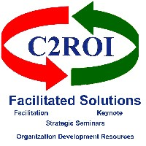

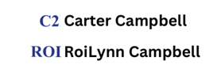
Five Levels of Evaluation

Kirkpatrick and Phillips

March 18, 2025

When discussing levels of evaluation, particularly in the context of training and development, the most referenced model is that of Kirkpatrick, which has been expanded upon by Phillips. Therefore, I will provide the information based on the expanded Kirkpatrick/Phillips model:
The five levels of evaluation are:
- Level 1: Reaction:
  - This level measures participants' initial reactions to the training or program. It assesses their satisfaction, engagement, and perceived value.
- Level 2: Learning:
  - This level evaluates the extent to which participants have acquired the intended knowledge, skills, and attitudes. It measures what they have learned.
- Level 3: Application (or Behavior):
  - This level examines whether participants are applying what they have learned in their job or real-world situations. It focuses on changes in behavior and performance.
- Level 4: Results (or Impact):
  - This level assesses the impact of the training or program on organizational outcomes, such as improved productivity, quality, or efficiency. It measures tangible results.
- Level 5: Return on Investment (ROI):
  - This level goes beyond results to quantify the financial benefits of the training or program. It compares the costs of the program to its benefits, demonstrating its financial value.
It's important to note that while the Kirkpatrick model originally contained 4 levels, the Phillips ROI model expanded to include the 5th level, which is the Return on Investment.

Info@c2roi.com www.c2roi.com 575.644.1981

