

**Session 2: Know Others**

**Table of Contents**

Contents

We are egocentric 2

Thought Speed 2

Thinking Drives Behavior 2

Social Skills 3

Emotional Bank Account 3

A conversation is crucial when 4

Things that pull us off goal 4

How we handle crucial conversations 4

Approaches to crucial conversations 4

# We are egocentric.

We often attribute other interactions to ourselves. This thinking can drive our behavior and leave control in other people’s hands.

|  |
| --- |
|  |
|  |

### Thought Speed

Your mind works at a rate of about 400 words per minute.

We talk at a rate of about 125 words per minute.

The difference gives you a gift you can use.

1. Search for total meaning

2. Listen for facts and feelings

3. Listen to nonverbal clues

4. Concentrate on your own attending behaviors

#### Thinking Drives Behavior

* You can only control your reactions and responses to other people and to situations that arise.
* Life's fundamental truth; the only person I can change is me.
* My relationship with you can only be as good as the conversation I have about you in my mind.
* Pause before reacting.
* Consciously choose an appropriate response

|  |
| --- |
| T |
| H |
| I |
| N |
| K |

|  |  |
| --- | --- |
| Tone of voice  Facial expressions  Hand gestures  Eye movements | Posture  Breathing  Space  Time |
|  |  |
|  |  |
|  |  |

## Social Skills

#### Emotional Bank Account

The amount of trust that exists in a relationship.

* Deposits build trust.
* Withdrawals break down trust.

|  |  |  |  |
| --- | --- | --- | --- |
| Place a check in the box | **Deposit** | **Neutral** | **Withdrawal** |
| Took you to a monster truck race for work well done |  |  |  |
| Asked you to complete and present the department report to the board |  |  |  |
| You receive a late birthday card |  |  |  |
| Bought you a fishing pole for your birthday |  |  |  |

## 

## Conversation is crucial when.

Stakes are high.

Opinions vary.

Emotions run strong.

### Things that pull us off goal

* Wanting to save face
* Wanting to win
* Seeking revenge
* Hoping to remain safe (Sugar Coating)
* Not being prepared

#### How we manage crucial conversations

### Approaches to crucial conversations

|  |
| --- |
| Avoid it |
|  |
| Face it but handle it poorly |
|  |
| Face it and handle it well |
|  |

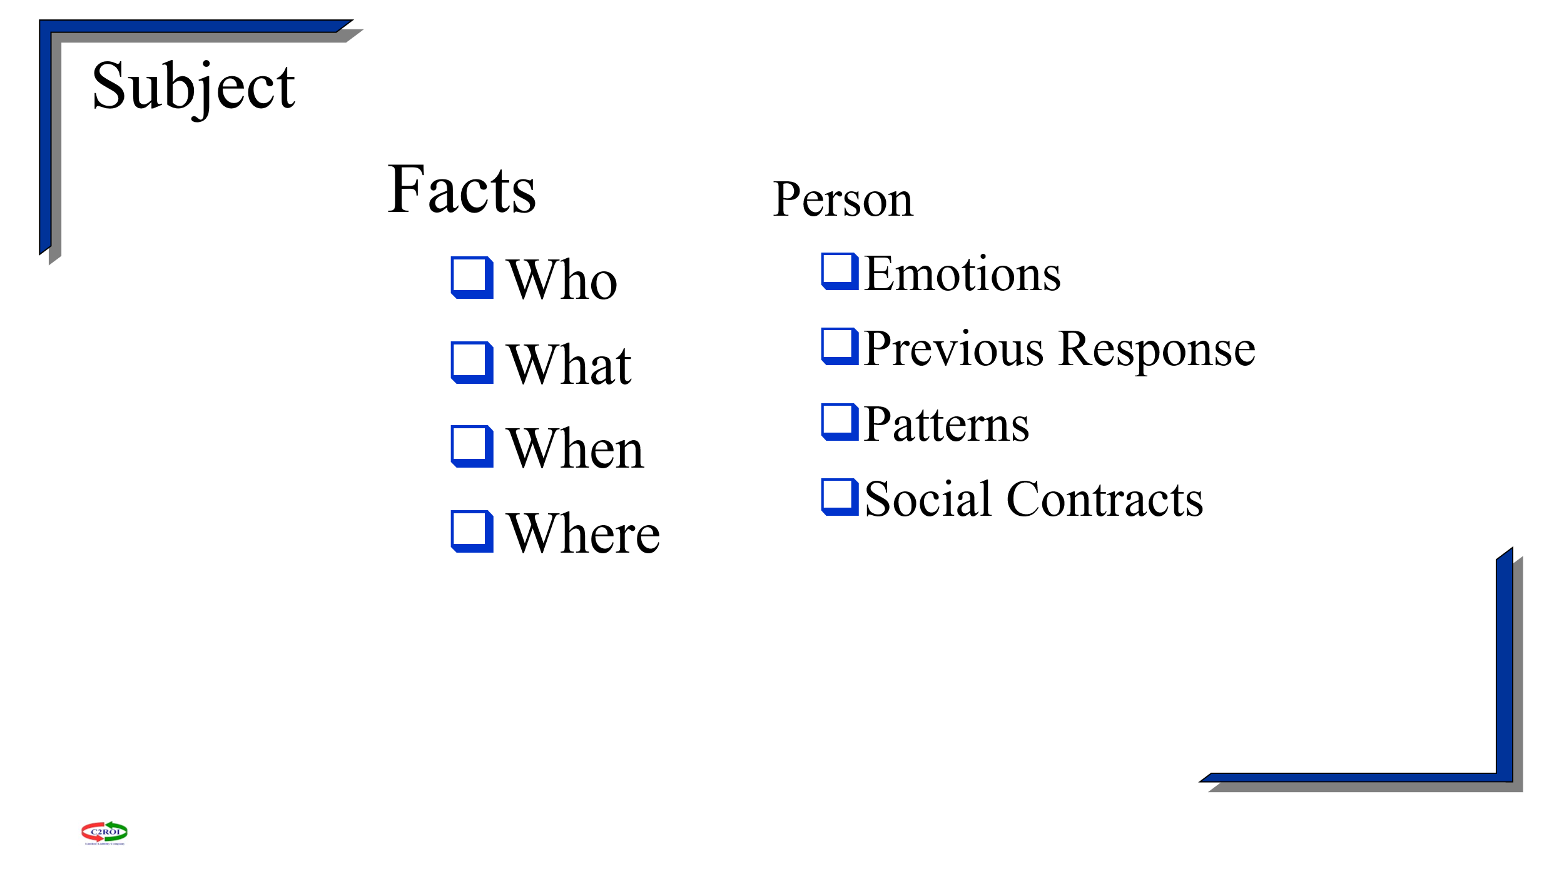

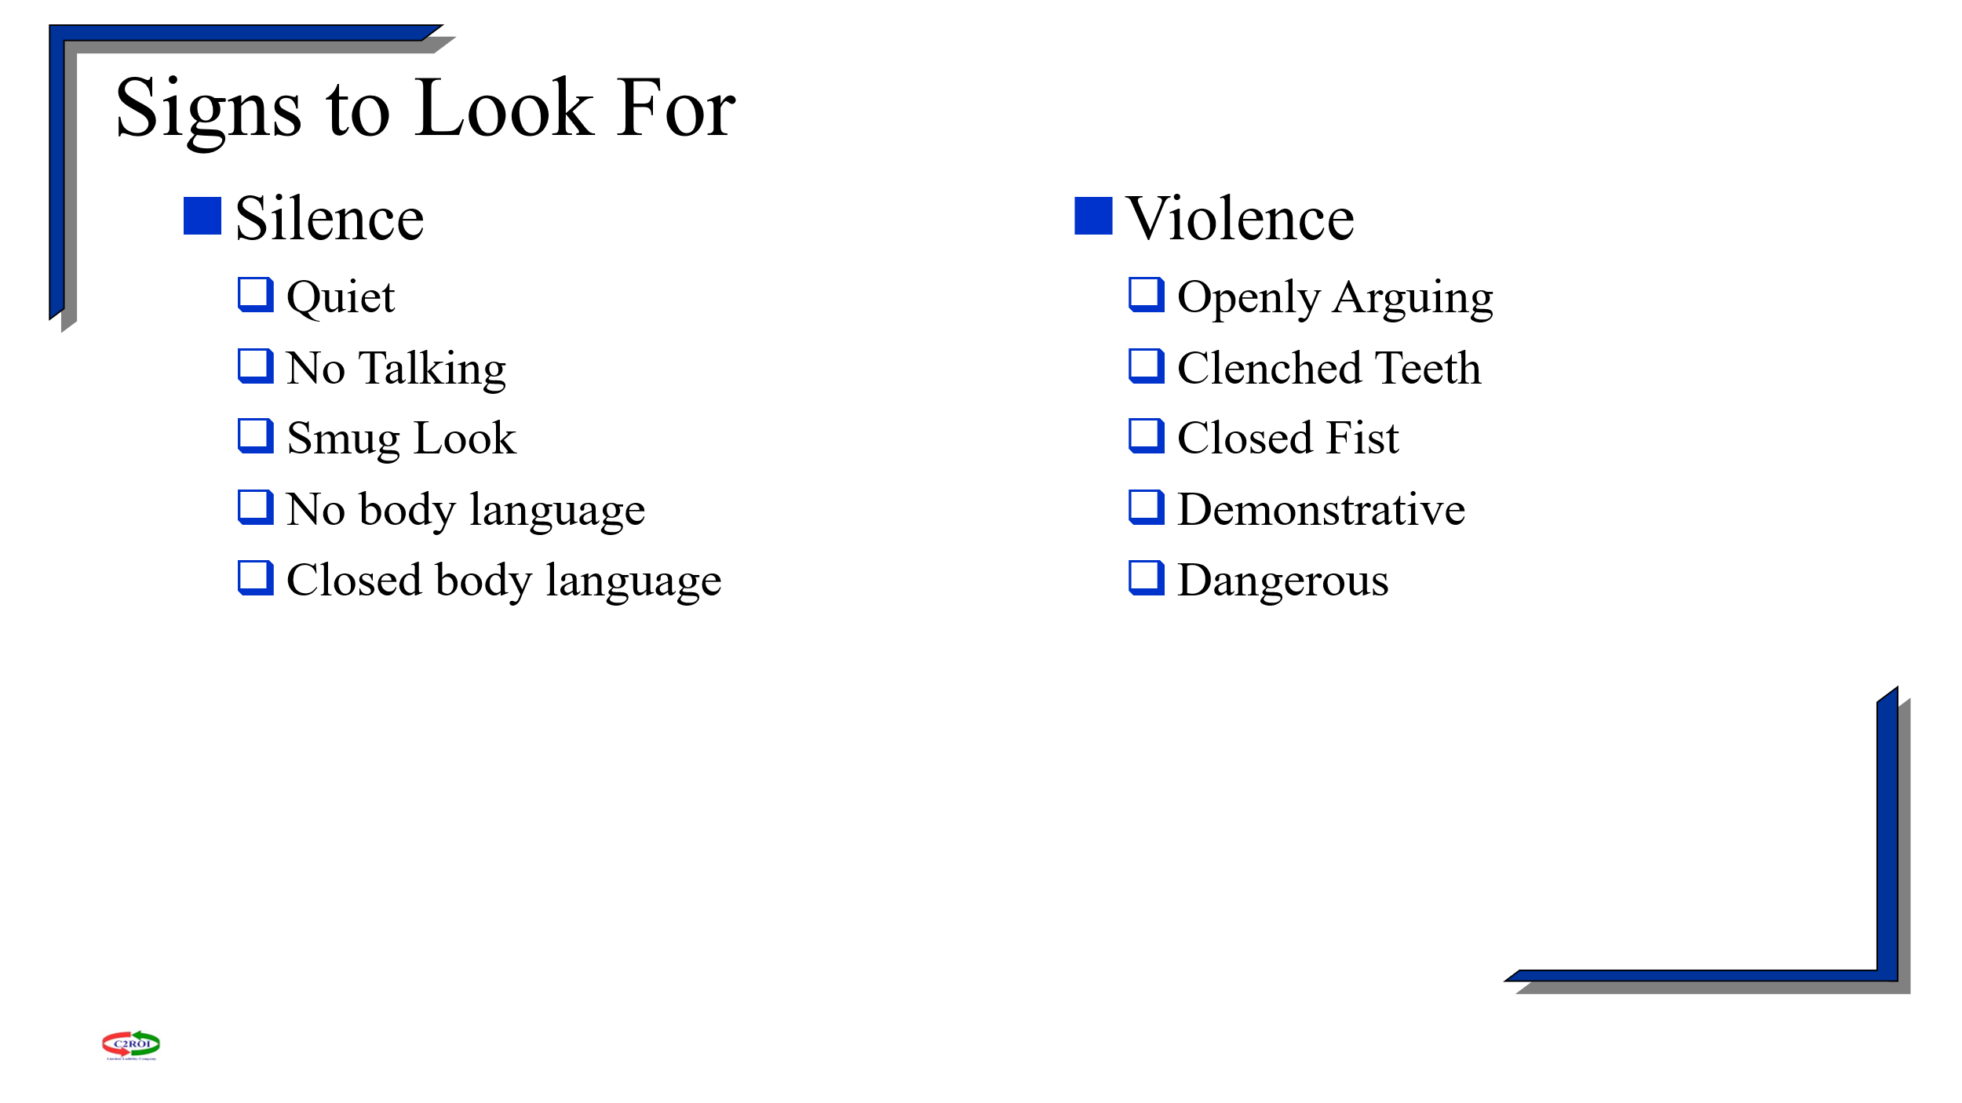

SAY WHAT YOU MEAN

MEAN WHAT YOU SAY

DON’T SAY IT MEAN